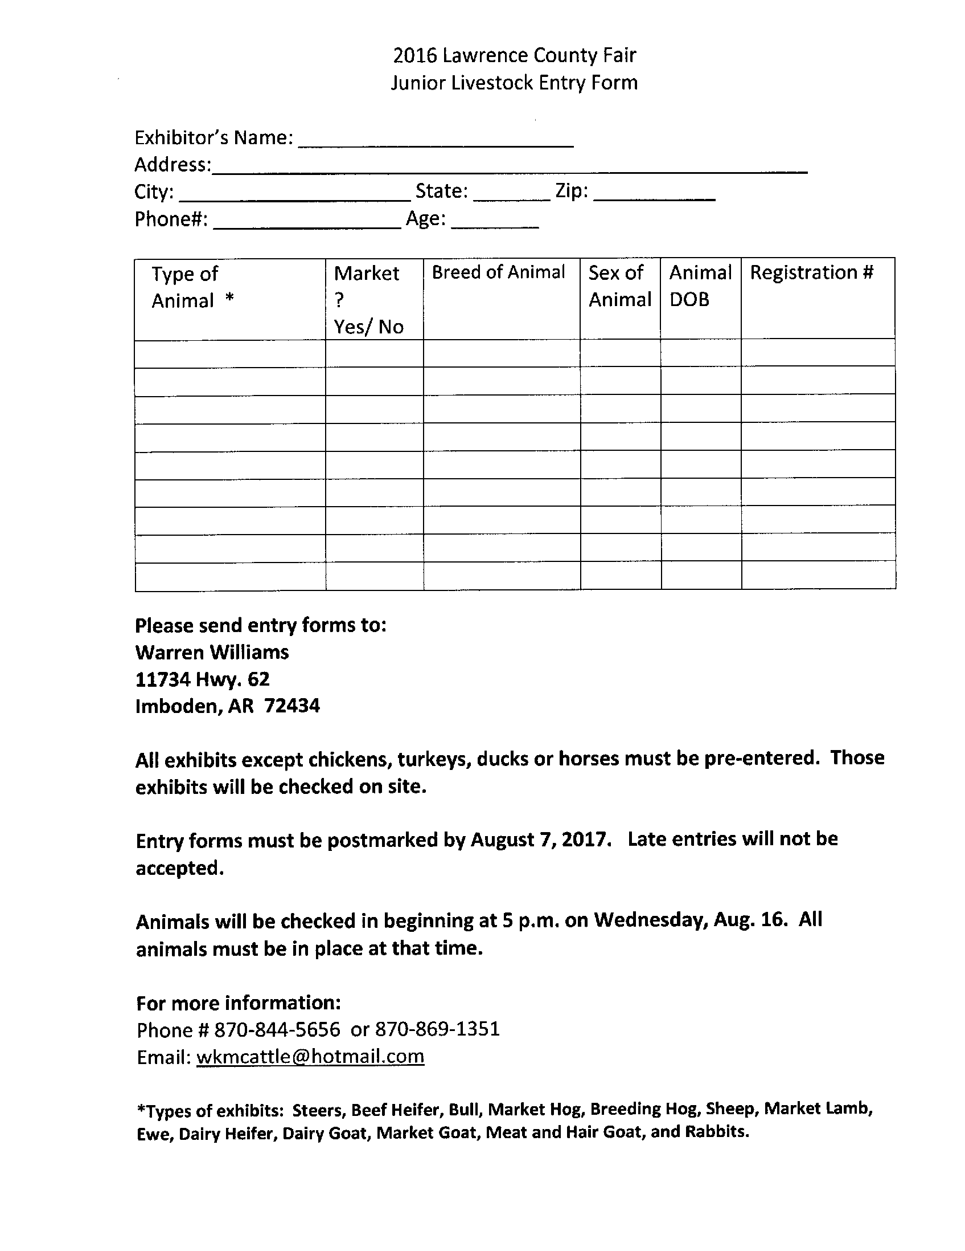

2017 Lawrence County Fair

Junior Livestock Entry Form